# Spring Framework Crash Course

## Spring initializr

<https://start.spring.io/>



## BuildTool

[Maven](https://mvnrepository.com/artifact/org.springframework/spring-context/5.3.18)/Gradle

(Artifact repo -> “set me up” for .m2 settings, etc.)

## Spring-Framework

<https://spring.io/projects/spring-framework>

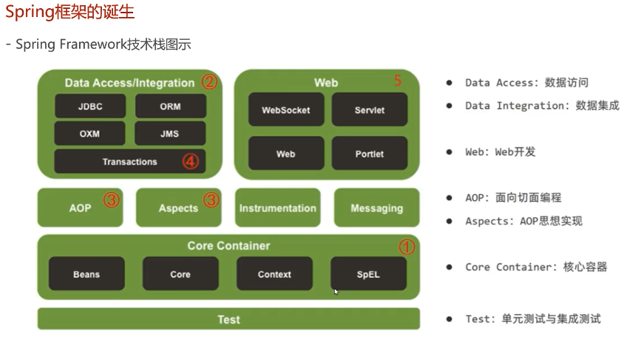

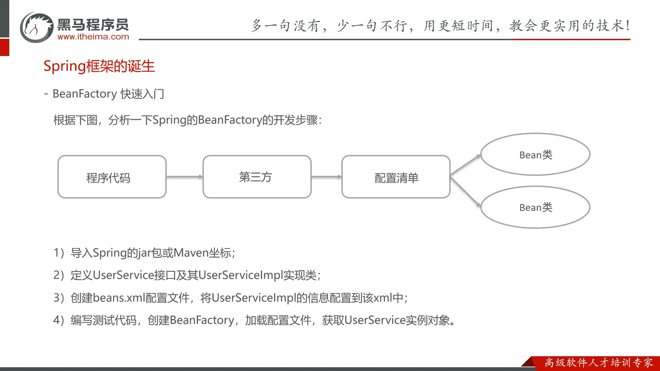

## Maven->pom.xml

|  |
| --- |
| <dependency>  <groupId>org.springframework</groupId>  <artifactId>spring-context</artifactId>  </dependency> |

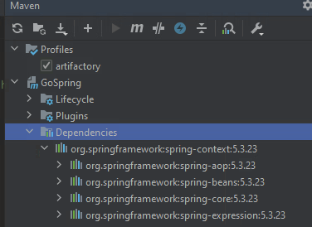

## IntelliJ

### Ultimate VS Community

auto recognizes Spring

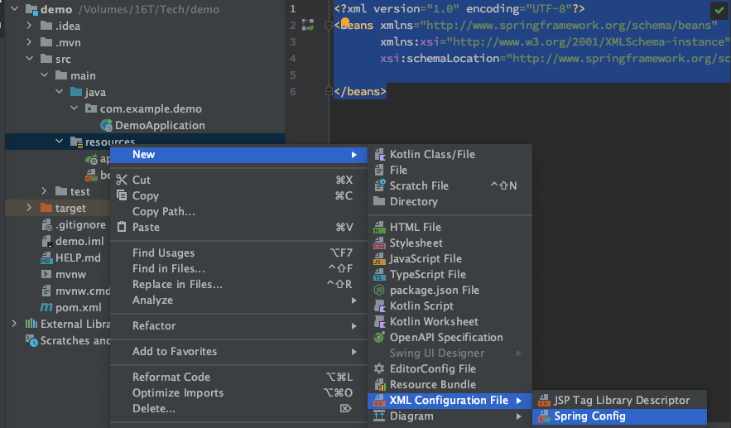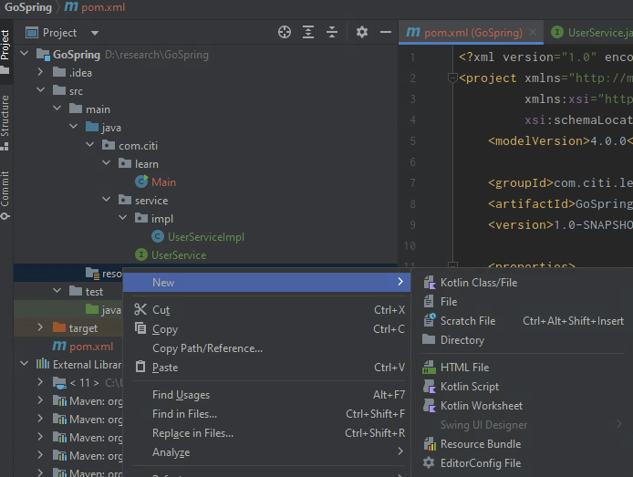

|  |
| --- |
| <?xml version="1.0" encoding="UTF-8"?>  <beans xmlns="http://www.springframework.org/schema/beans"  xmlns:xsi="http://www.w3.org/2001/XMLSchema-instance"  xsi:schemaLocation="http://www.springframework.org/schema/beans http://www.springframework.org/schema/beans/spring-beans.xsd">  </beans> |

ApplicationContext

